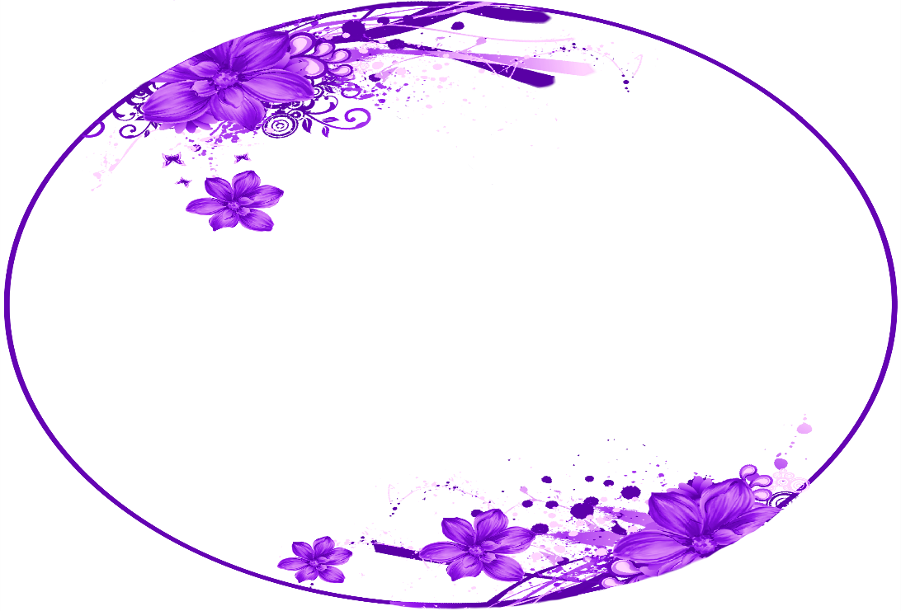

Ara

Happy 18th Birthday

From: Evermoist